**In Search of the “Hill Country”:**

**Using the Foursquare API to Delineate a Vernacular Region in Texas**

William Flynn, Ph.D.

March 10, 2020

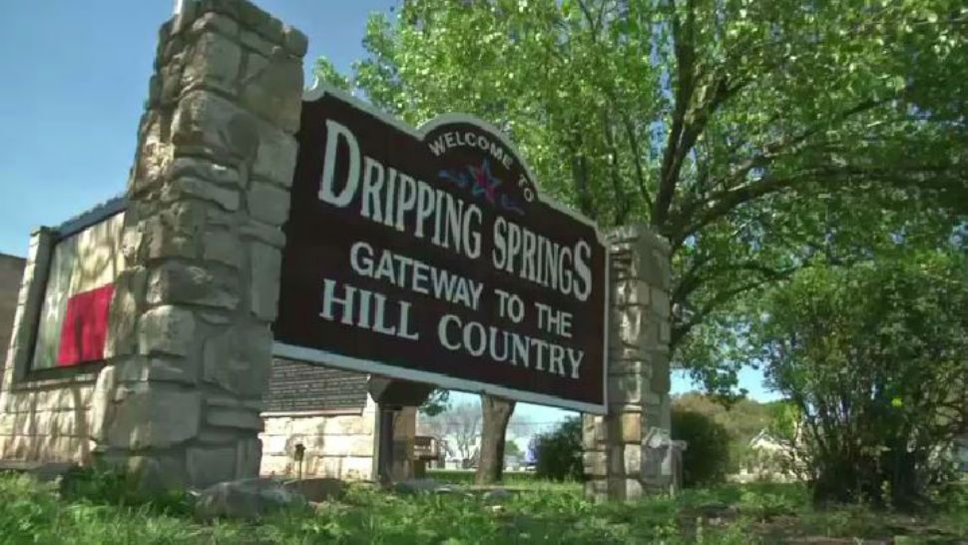

*Located just a few miles west of Austin, the town of Dripping Springs, Texas*

*(population 3,876) is nicknamed the “Gateway to the Hill Country”*

**I. Introduction**

Given that Texas is one of the largest states in the country, it is often subdivided into many regions, some of which include the Panhandle, Big Bend, Coastal Plains, and Rio Grande Valley. A well-known and widely visited region of Texas that has often been inconsistently defined is the Hill Country. It basically comprises the portions of Central and South Texas that are situated on the Edwards Plateau, to the west of the Balcones Escarpment that runs along the cities of Austin and San Antonio. This area is a favorite spot for scenic drives, leisure, and outdoor recreation, and it has even become a frequent landing destination for retirees and snowbirds.

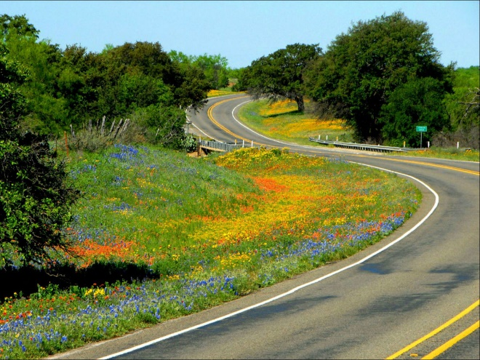  
*A typical spring wildflower scene in the Texas Hill Country.*

In the study of geography, there are three types of regions—formal, functional, and vernacular. Formal regions are areas where people share one or more measurable traits, such as a common language, system of beliefs, nationality, or even physical characteristics. Examples of formal regions include the country of Peru, the Sahara Desert, and a Francophone region of Canada. Functional regions are set up around a system of interactions, such as a public transit network or the delivery area of a pizza restaurant. Vernacular or perceptual regions are defined by people’s attitudes, feelings, and perspectives about an area. These regions reflect a “sense of place”.

Given the “Hill Country” name, the region seems to reflect physical geography, and one might think that it would be fairly easy to determine where the Hill Country begins and ends, but this is rarely the case with vernacular regions. Here is one representation of the places of interest within the region from tourist website TexasHillCountry.com:

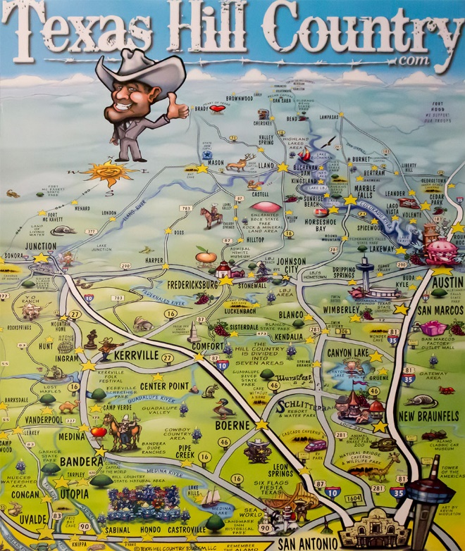

The NBC affiliate in San Antonio, television station WOAI, gives its viewing area separate weather forecasts for a so-called Hill Country Zone that extends from New Braunfels back to Rocksprings and covers six counties:

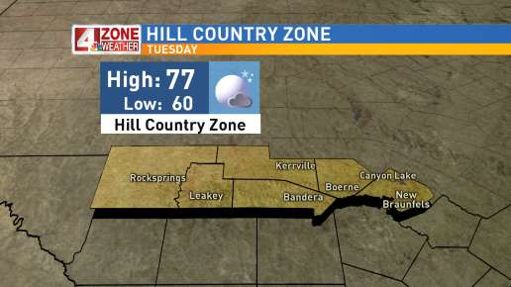

John Nisbet, a realtor based out of New Braunfels in Comal County, posted this interesting graphic on his company’s website. It poses the question, “Where is the Texas Hill Country?” and shows four different representations as provided by Texas Parks and Wildlife, Texas A&M Real Estate Center, Texas State Historical Association, and the United States Department of Agriculture. This provides a consensus ballpark as to what is located within or outside the Hill Country region, but it is clear that there is a difference of opinion.

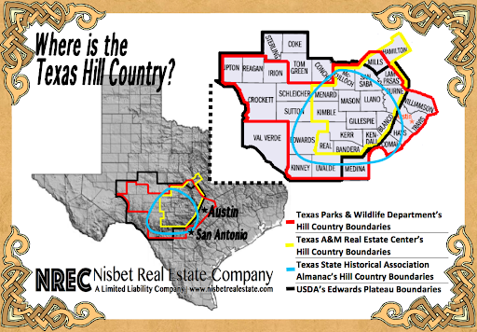

Human geographers have long been interested in attempting to map vernacular regions. Several decades ago, the phone book white pages were a frequently used vehicle for quantifying the application of regional names into place / business names. In the example below, John Shelton Reed was interested in delineating the vernacular region of “Dixie” in the U.S. South, and he did so by perusing city phone books to compare the ratio of business names beginning with “Dixie” versus those starting with “American.” Through some manual interpolation, Reed was able to identify the core and periphery of the “Dixie” vernacular region.

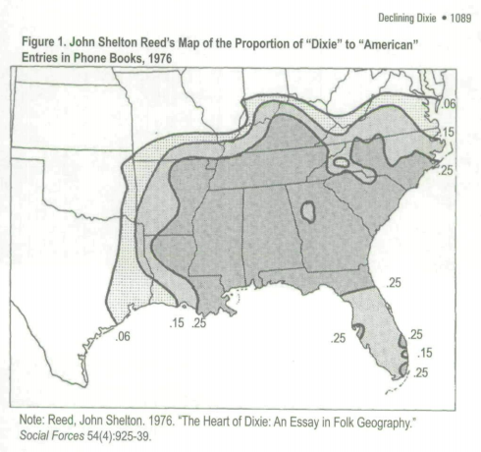

There are many examples of businesses and institutions in Texas that promote the Hill Country in their names, such as Hill Country Eye Associates of New Braunfels, Hill Country Automotive of Boerne, and Hill Country High School in Kerrville. Businesses tend to incorporate the regional name in order to communicate their service area and to exploit the usually positive place attachment and pride shared by the locals and potential clientele.

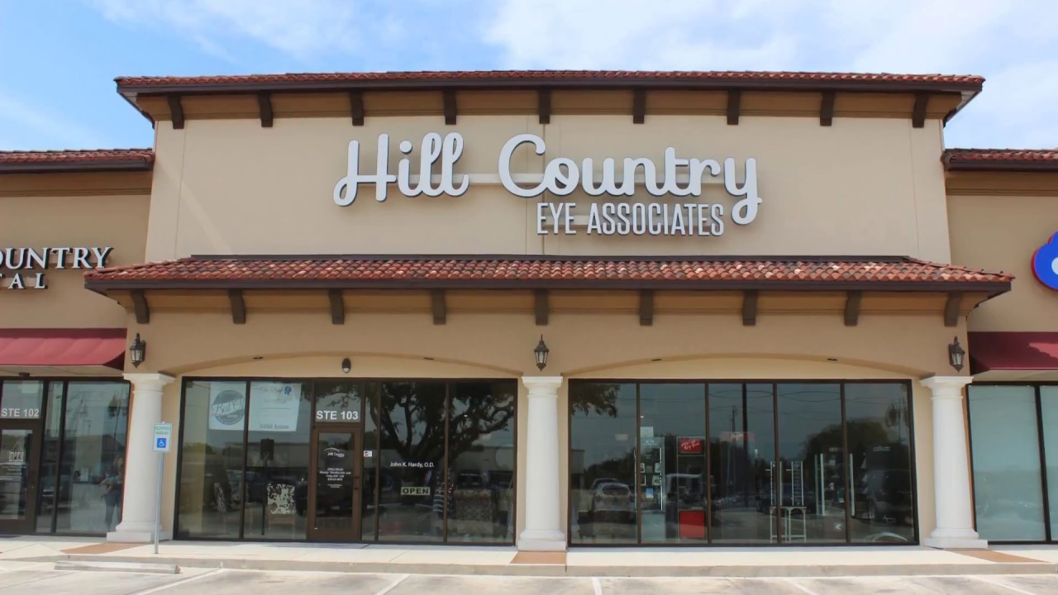

This project will attempt to better understand the perceptual geography of the Texas Hill Country, and, in doing so, serve as a case study to modernize the old-school methodology of geographers retrieving and analyzing data on business names that incorporate regional references.

**II. Data**

In order to delineate the extent of the “Hill Country” region of Texas, this study will leverage Foursquare’s Places API. This repository offers a comprehensive inventory of venues that can be queried to harvest an inventory of sites, ranging from businesses to churches and from schools to medical offices that play the geography card and promote their ties to the local area by featuring “Hill Country” in their name. The observed frequency of “Hill Country” place names will be used to interpret and illustrate the bounds of the vernacular or perceptual version of this Texas Hill Country region.

While Foursquare can boast an impressive total catalog of more than 100 million venues worldwide that can be readily consumed by apps, one limitation with the service is that each call against the API will only return a maximum of 50 venues up to a search radius of 100 kilometers (roughly 62 miles). Each account is also subjected to a daily quota of API calls. This requires that the researcher be efficient with their strategy in using the Foursquare API.

Thus, a hierarchical approach will be the most cost-effective way to leverage the API and assemble the inventory of “Hill Country” venues. Since the Texas Hill Country is relevant to a single state, by taking the bounding box of the Lone Star state (minimum vs. maximum latitudes / longitudes), a grid of sample points evenly spaced by one degree of latitude/longitude will provide the starting point for the search of “Hill Country” venues. Using the Nominatim reverse geocoding package within the GeoPy library, it is possible to filter these one-degree spaced points to those located in Texas (remove points located in Mexico, New Mexico, Oklahoma, Arkansas, Louisiana, and the Gulf of Mexico).

In Texas, one degree of latitude or longitude equates to about 60 miles of great circle distance. Foursquare offers a search radius that is circular. Circles are problematic because they do not tesselate like triangles or hexagons. This means that, depending on the constant value set for the radius of the search circle, the resulting set of circles will produce underlaps (radius is too small) or overlaps. In order to ensure completeness and include all venues that have “Hill Country” in their name, it is preferable to have the overlap. It is easy to filter out retrieved duplicates via the venue ‘ID’. It would be a shame to miss out on some ‘Hill Country’ venues because the search circles did not have a large enough extent to cover relevant areas.

Following the first round of searches, any sample point that returned exactly 50 venues (the API limit) will require a deeper dive because there may be more relevant venues in the vicinity that may have been missed. A second round of searches will be devised, with the search points set at one-half of the previous spacing. Thus, a coordinate pair that found 50 venues in the first round will be turned into a set of nine new coordinate pairs with one-half degree of latitude/longitude spacing centered around the original coordinates. The neighborhood search radius will also be reduced from 75,000 meters to 37,500 meters. By turning one large search circle into up to 9 smaller search circles, it increases the likelihood that fewer than 50 venues will be returned per search point.

This process will be continued with increasing granularity until all search points return fewer than 50 venues. This will yield confidence that the Foursquare API searches have produced an exhaustive list of “Hill Country” venues, and accomplishing this through a low cost in API calls.

At this point, the inventory of statewide “Hill Country” venues will be cleansed, analyzed, and plotted. Since the Foursquare API returns actual lat/long coordinates for each venue, the “Hill Country” venues can be mapped to show the spatial pattern of their distribution. Using the Folium library for Python, an interactive cluster map can portray the locations of the “Hill Country”. A second way that the distribution can be illustrated is through a hexbin mapping technique, where a tessellating structure of hexagons can receive choroplethic shading to depict the frequency of “Hill Country” venues. Through a combination of tables and maps, the vernacular portrayal of the Texas Hill Country in this study will be compared against other existing interpretations of this popular region.